Employee Timesheet Entry
Working for JFC has never been easier! The company that you have been assigned to is part of JFC’s WebTime program. WebTime is a program that will allow you to complete your time card online and electronically submit it to your supervisor for approval. Once approved, it will automatically be forwarded to JFC’s payroll department. No need for manual time slips or physically dropping them off.
How do you get started? It’s easy!
You will be able to go to the following website, time.jfcstaffing.com, to login and fill out your time card for the week. All you need to know is your Employee ID number and which JFC company you are assigned. This Employee ID number will be both the User Name and Password. It will prompt you to change your password upon first login.

Choose the proper JFC Company to login

The “Forgot Password?” link is available on the home screen if you have trouble remembering your password. Simply click the link and instructions on how to reset your password will be sent to the email address we have on file. This is one of the reasons it is important to keep information updated in our system. So please notify us of any changes in contact information, especially your email address.

All time submission for the previous work week needs to be submitted by 9 am on Monday of the following week to ensure it is processed properly. Failure to do so may result in delayed payment.

Home Screen
This is the home screen that will appear when you first login.
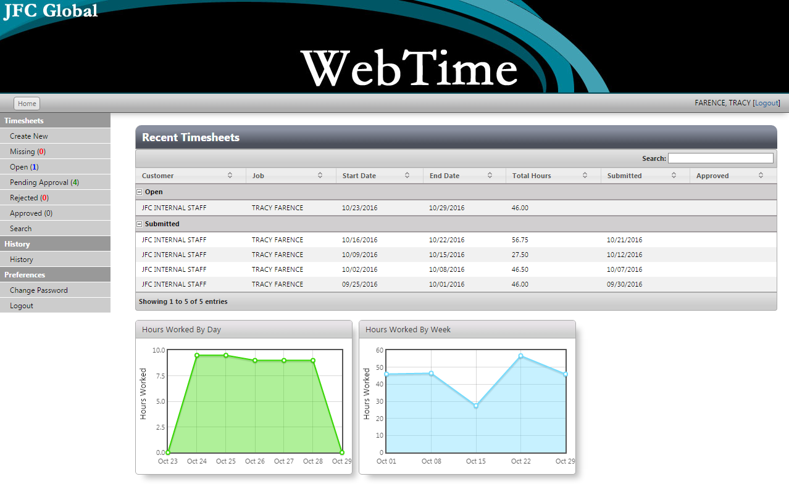

You will see several options along the left side of your screen:
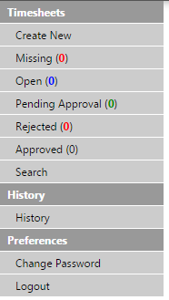
The Missing, Pending Approval (Submitted), Rejected, and Approved options allow you to access any of your timesheets by status. Clicking any of these 4 statuses will display the appropriate timesheets in the Recent Timesheet grid.
Open allows you to edit a previously entered timesheet that is yet to be submitted.
Create New allows you to create a new timesheet.
Create New
When the option to Create New is selected, you must first select a date from the calendar that pops up (see below). The periods that are selectable will be the current work week and 1 work week prior. Once the date is selected, you will automatically drop into the Timesheet Entry window. Only 1 timecard can be created per work week.
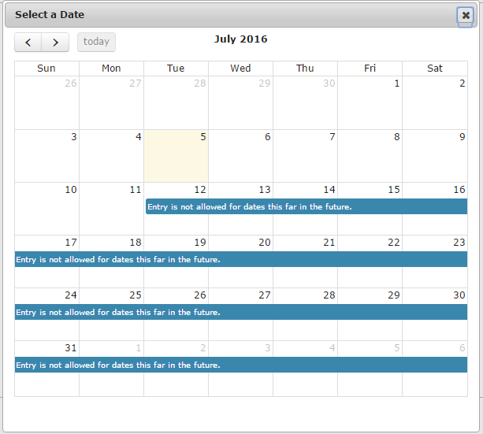

Timesheet Entry
Entering timesheet information is very straightforward.
Pay Type – Regular Hours is the default. Overtime is automatically calculated when received by Payroll.
In/Out – Enter the time you clocked in and out for the day.
Lunch – Enter the amount of time taken for lunch, formatted in hours (not minutes). For example, if 30 minutes is taken then 0.50 hours should be entered. See the quick reference chart below:

Minutes | Hours
15 | 0.25
30 | 0.50
45 | 0.75
60 | 1.00
Comments – Use this field for any special notes such as vacation time, sick leave, on-call time, holiday, etc. When entering comments for a day that has no time worked, you will need to enter zero for In, zero for Out and zero for Lunch, which will default to 12am to 12am as per below. Comments for blank time lines are not transmitted to Payroll.

Upload File – Use this function if you have any approved JFC forms or documentation that needs to be included.
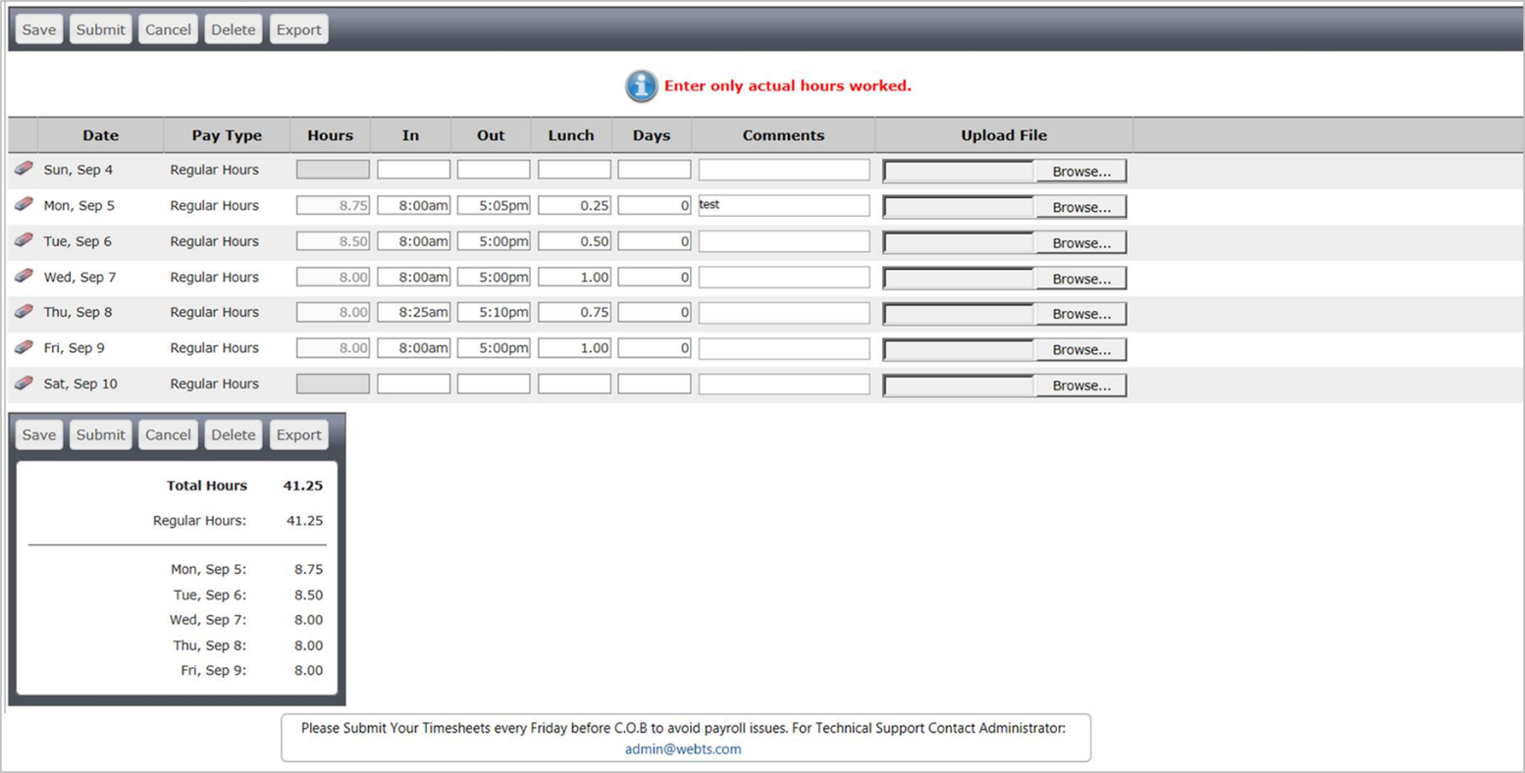

Save – Allows the timesheet data to be saved and becomes available to be edited later.
Submit – Allows you to submit the entered time for approval by the supervisor.
No changes can be made to this timesheet once it has been submitted.
Cancel – Allows you to exit out of the window without saving the entered timesheet data.
Delete – Deletes the current time sheet.
Export – Transfers data to a savable file for your personal records.
– The eraser button found next to each time entry line can be used to clear all fields. When selected, you must save before editing is available again. If clicked by accident simply hit Cancel.

Once you have submitted your timesheet, it will go to your supervisor for approval. The deadline for employee submission is 9 am on Monday. If submitted after 9 am we cannot guarantee on time payment. If approved, it will get transmitted to Payroll for processing. If rejected, you will receive email notification that means there is a discrepancy or error that needs to be corrected. You must correct and resubmit the timecard for approval to be paid.
* Timecards will not be paid until approval status has been achieved. *

