Client Approval of Timesheets
Working with JFC has never been easier! WebTime is a program that will allow our temporary employees to complete a time card online and electronically submit it to you for approval. Once approved, it will automatically be forwarded to JFC’s payroll department. No need to worry about manual time slips.
How do you get started? It’s easy!
You will receive an email notification. From there, you will be able to go to the following website, time.jfcstaffing.com, to login and approve time cards on a weekly basis. Your User Name will be your email address and your password will also be your email address (case sensitive for both). It will prompt you to change your password upon first login.

Choose the proper JFC Company to login

The “Forgot Password?” link is available on the home screen if you have trouble remembering your password. Simply click the link and instructions on how to reset your password will be sent to your email address.

All time cards must be approved by 12:00 pm (noon) on Monday. Failure to do so may result in delayed payment to employees.

Home Screen
This is the home screen that will appear when you first login.
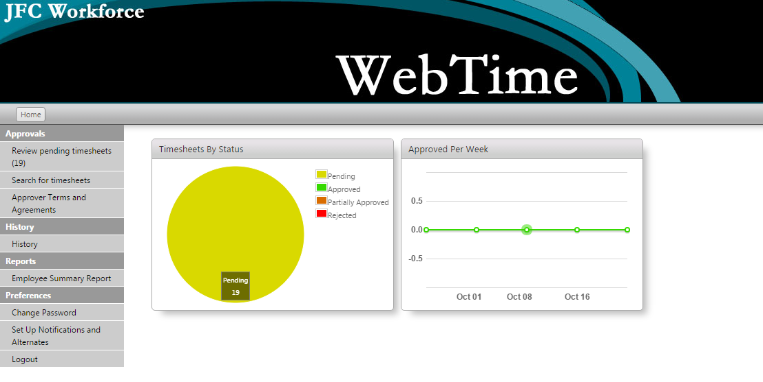
You will see several options along the left side of your screen:
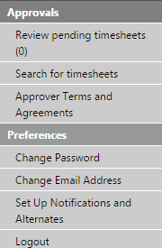
The Approvals section of the Approver Home page allows the Approver to Review pending timesheets, Search for timesheets, or view the Approver Terms and Agreements document.
The Preferences section allows the Approver to change his or her password or set up/edit email notification requirements.

Approvals
Once submitted by the employee, timesheets will be available for review by the Approver. The option to “Review Pending Timesheets” allows the Approver to view all timesheets submitted by the temporary employees assigned to that Approver.
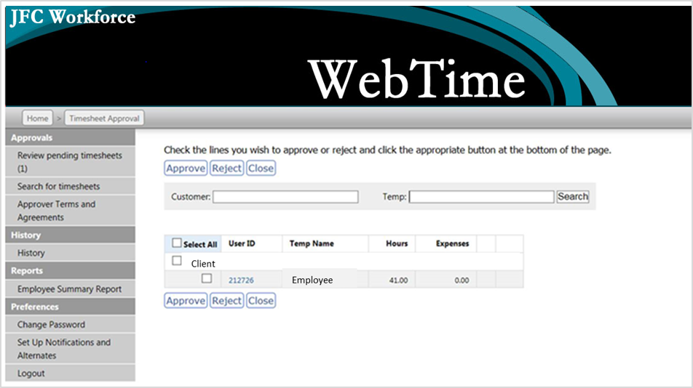
Select for timesheet detail

By clicking on the blue User ID field shown above, it allows the Approver to view the time submission in greater detail.

The Approver can do one of four things with each submitted timesheet:

Approve – Reviewing a timesheet entry and then selecting the ‘Approve’ button acknowledges that the time entered is correct and ready to be paid.
Once approved, it is submitted to the JFC Payroll department and is no longer available in the timesheet approval window.
Reject – Reviewing a timesheet then selecting the ‘Reject’ button will change the status of the timesheet from submitted to open. Approvers reject timesheets if they are not satisfied with one or more of the timesheet details.
When rejecting a timesheet, the Approver is prompted to enter a reason so that the temporary employee has an indication as to why the timesheet was rejected. This is highly recommended to ensure quick and accurate payment to employees.
Once rejected, email notification will be sent back to the employee letting them know they need to correct the error and resubmit for approval. When the employee resubmits the timecard the approval process begins again.
Timecards will not be sent to Payroll for processing until an approved status is achieved.
Close – Allows the Approver to exit out of the window without approving or rejecting any timesheet data.
Approval History – This window allows the Approver to view information about each timesheet whenever the status of that timesheet changes.

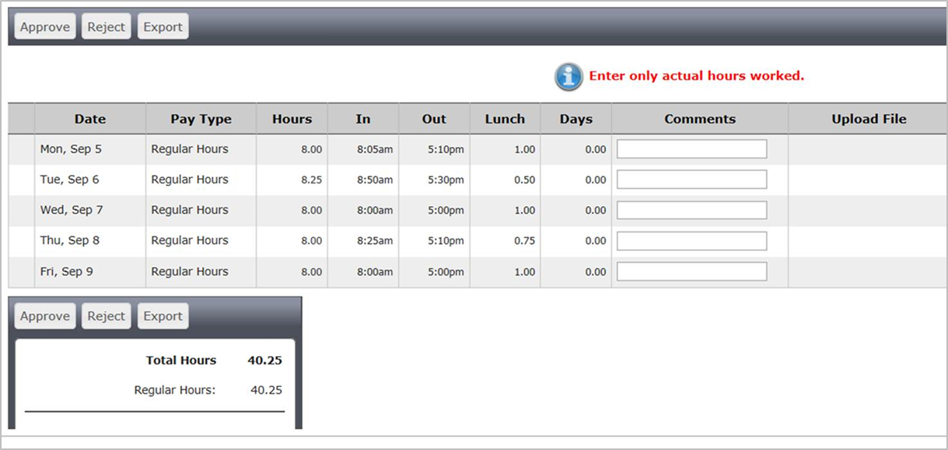

It is also possible to search for specific timesheets no matter when they were submitted or what their current status is. Simply select “Search for timesheets” from the left toolbar and enter your search criteria.

It is also now very easy to customize your own personal notification settings. Under “Preferences” select “Set Up Notifications and Alternates.” This will bring up the options below:

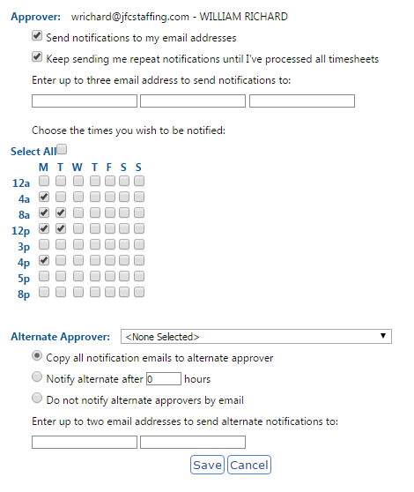

If Alternate Approver is not available, please contact JFC Payroll Department

